1) list all files larger than 1MB in current directory and save output to a file
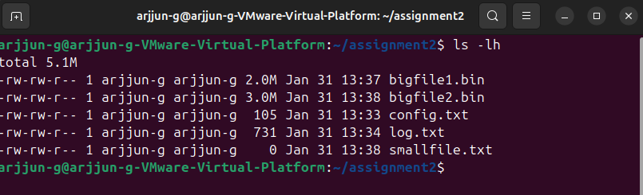
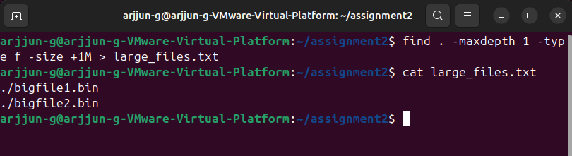
2) replace all occurrences of "localhost" with "127.0.0.1" in config.txt and save as updated_config.txt
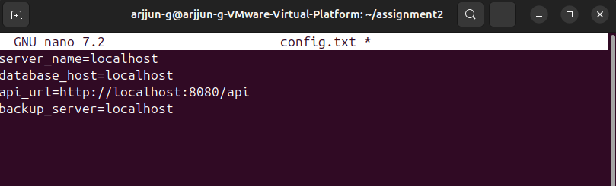
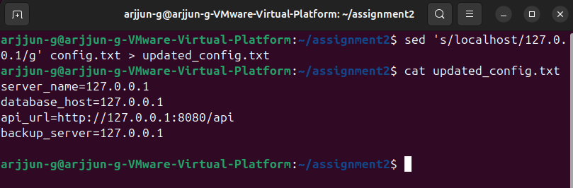

3) search log lines containing "ERROR" but exclude lines containing "DEBUG", save to filtered_log.txt
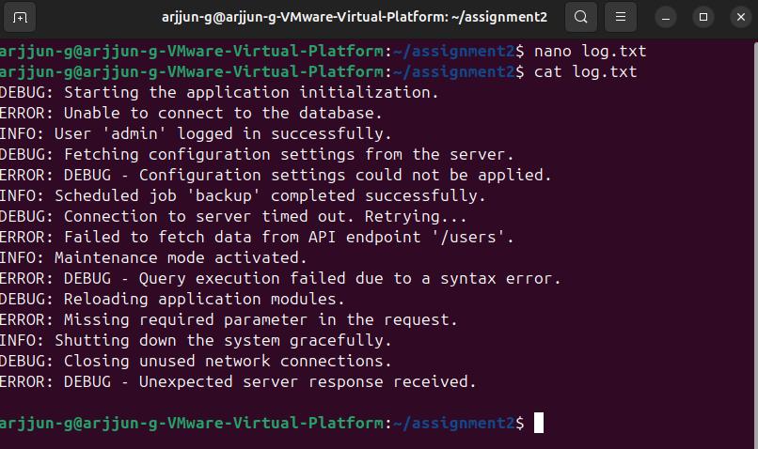
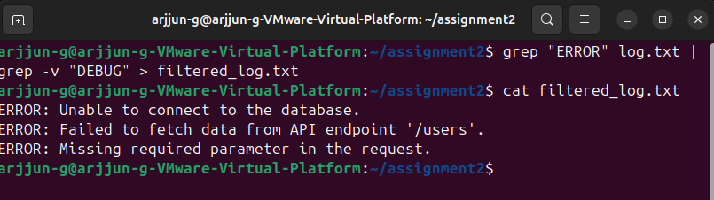
4) Identify the process with the highest memory usage and terminate it
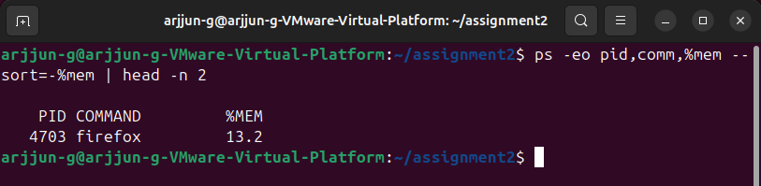
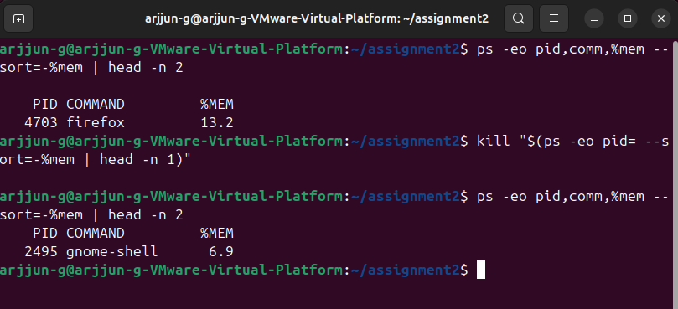
5) use the networking tool to Print all available gateways in a sorted manner
